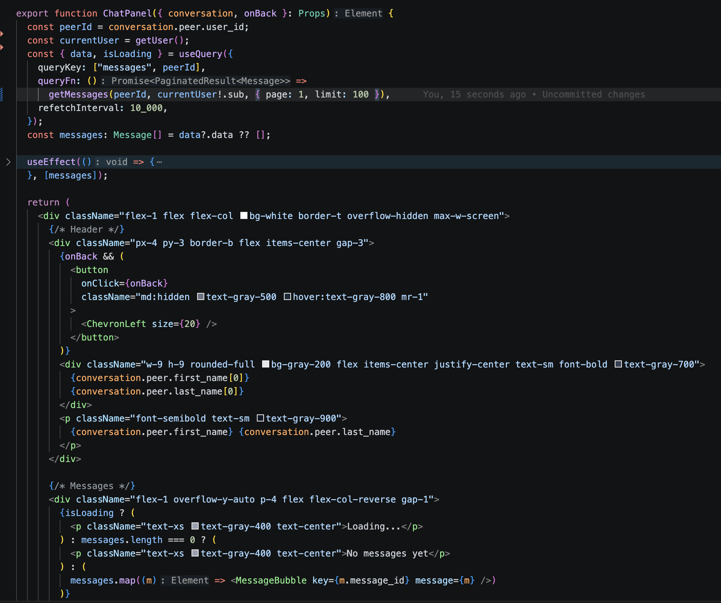 Chat Panel Component The messaging component renders a conversation thread between two users. It handles cursor-based pagination to load older messages, marks messages as read on view, and differentiates sent vs received messages visually. Real-time feel is achieved through periodic refetching or query invalidation on send.

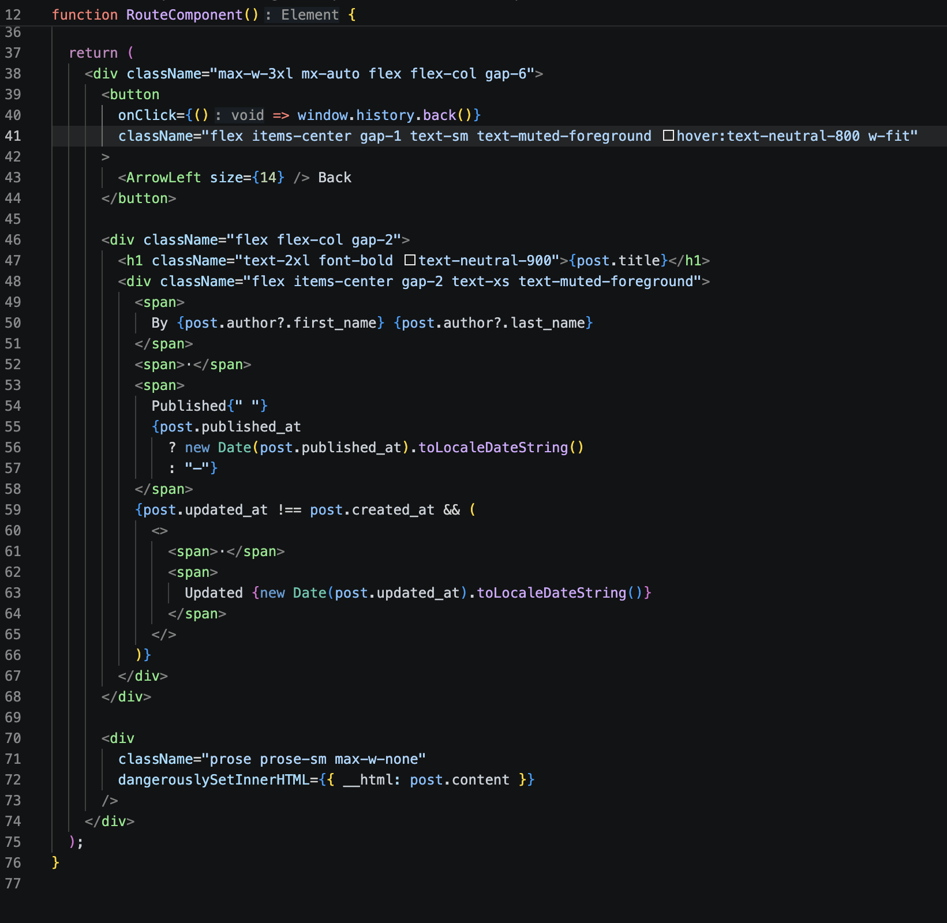

Blog Page The blog reading page renders rich text content generated by the TipTap editor using React's HTML rendering capability. Since content is authored exclusively by authenticated users through a controlled editor, the output is restricted to safe semantic HTML tags

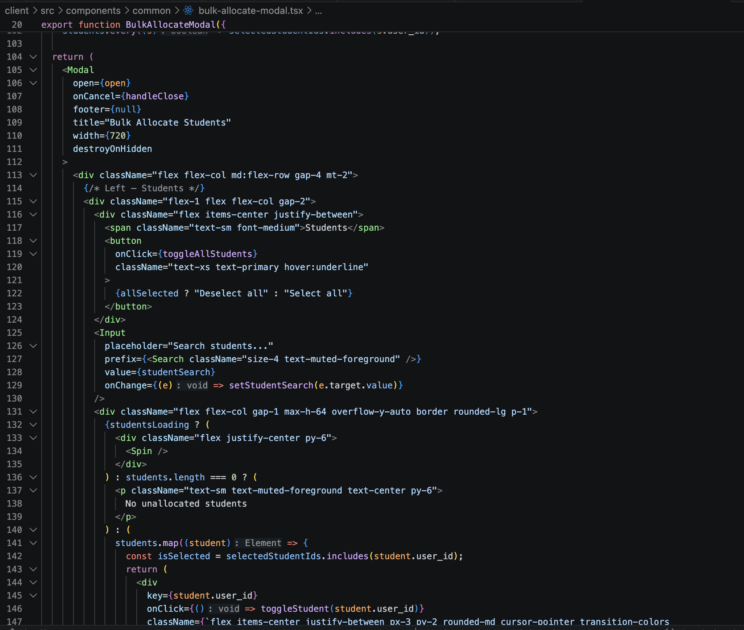

Bulk Allocation Modal This component allows staff to select multiple unallocated students and assign them to a single tutor in one operation. It uses the AllocateDto which accepts a tutor_id and an array of student_ids. The backend processes each allocation in a loop, skipping already-allocated students and returning a result object with allocated and skipped arrays so the UI can report partial successes.

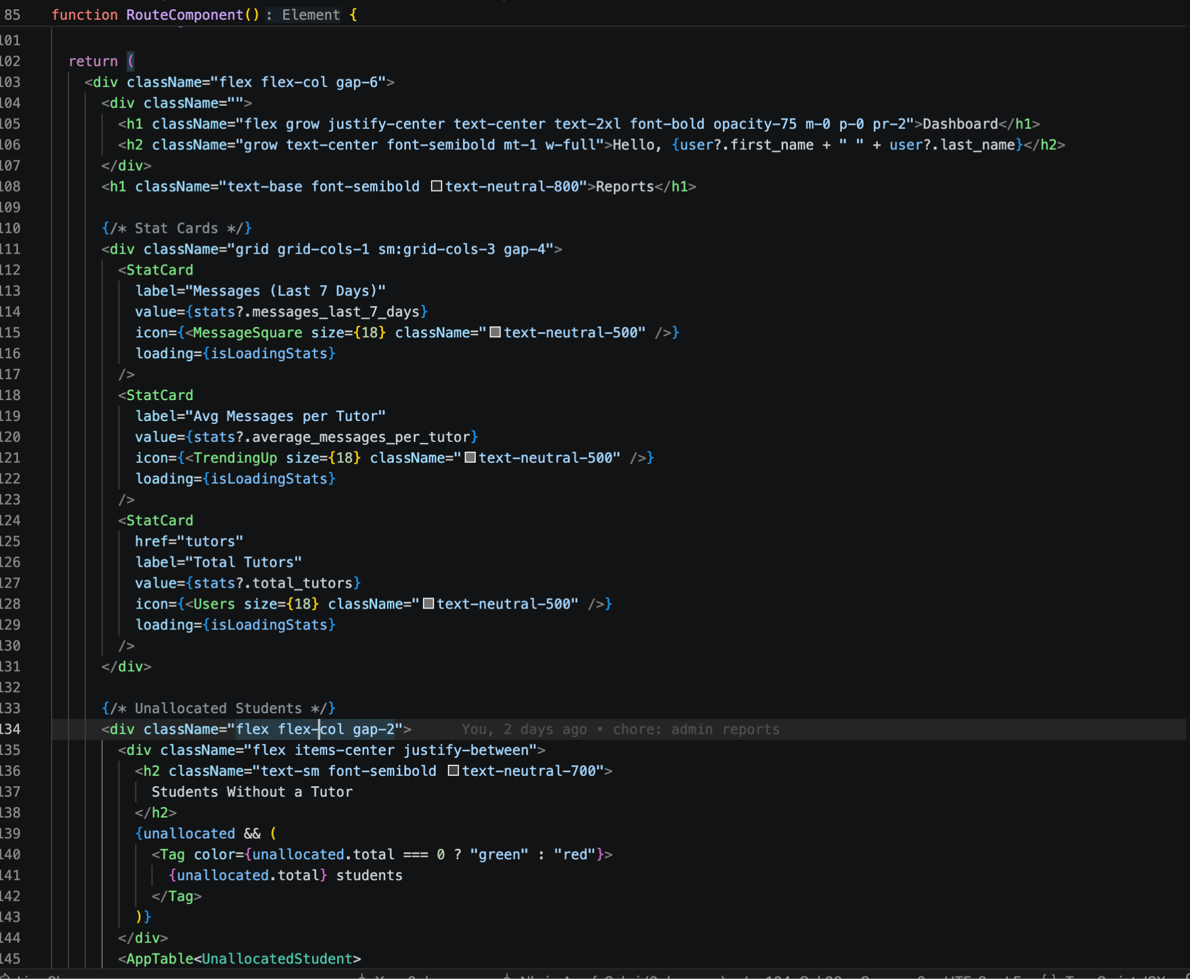

Staff Dashboard / Admin Home The staff home page combines three data sources — platform statistics, unallocated students, and inactive students — into a single reporting view. Stat cards show message volume and tutor counts. Two AppTable instances display exception reports: students with no tutor assigned, and students with zero interactions in the last 7 or 28 days, helping staff identify at-risk students.

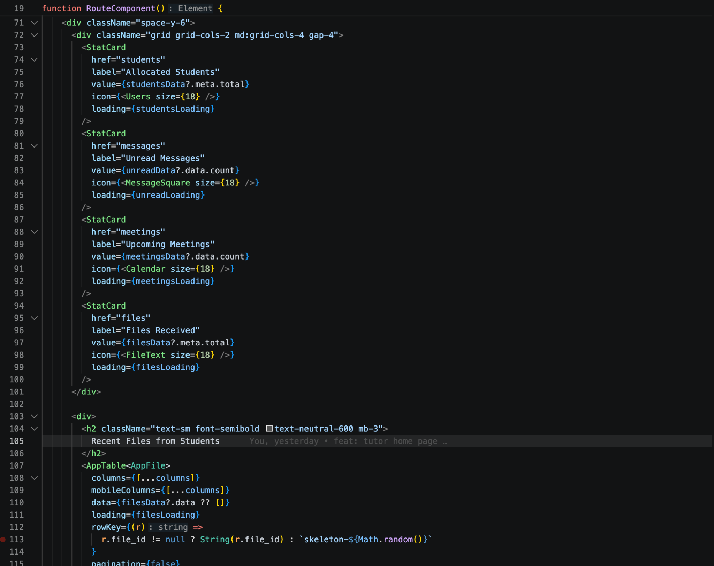

Tutor Dashboard The tutor home gives a personalised overview using four stat cards — allocated students (from pagination meta), unread messages, upcoming meetings, and files shared with them. Below the cards sits a table of recent files shared with the tutor filtered to shared_with_me, giving quick access to student submissions without navigating away.

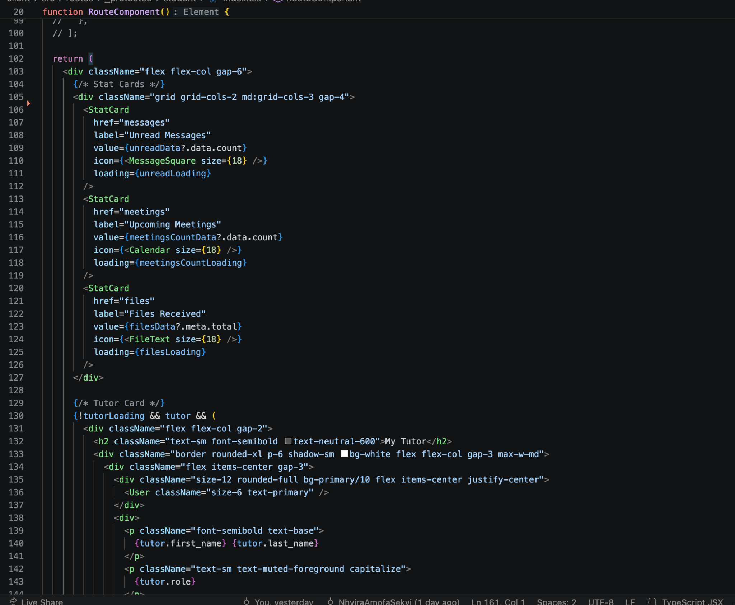

Student Dashboard The student home mirrors the tutor dashboard but from the student's perspective. It shows unread messages, upcoming meetings, and files shared with them via stat cards. Below, upcoming meetings render as cards (not a table) since the meeting model has richer fields like location and join link. Files shared by their tutor appear in an AppTable with a download action. A tutor card at the top shows their assigned tutor's name, email, role, and allocation date.

